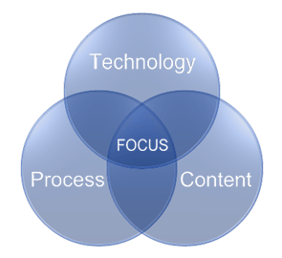
Gain Focus Technologies
142 Greenwood Drive
Daphne AL 36526
www.gainfocus.biz

Scenario: A vendor is also a customer, and you want to offset the amount owed to the vendor by their A/R.

 | AP Trade |  |  | AR Trade |  |  | Notes
Beginning Balance |  | 50,000 |  | 10,000
Issue Credit memo to Vendor, charging the offset to AR Trade | 10,000 |  |  |  | 10,000 |  | AP Trade GL account is now $40K, as in the AP Aging for this vendor The AR trade account is zero, but the AR Aging falsely shows $10K in Receivables
Write off the $10K in AR Trade to AR Trade - in andout of the same GL Account. |  |  |  | 10,000 | 10,000 |  | This removes the item(s) from the AR Aging, but has zero effect on the General Ledger. Both AR and AP Agings should now be correct.

